Java Notes
- Static v/s Non-Static Methods:
In Java, you can call a method from the same class within another method or the main method by simply using the method name if it is static, or by using an instance of the class if it is non-static. Static methods can be called directly by their names from other static methods or by using the class name. Non-static methods need an instance of the class to be called from other non-static methods or the main method.
When the methods are static, you can call them directly by their names:

public class MyClass {
public static void main(String[] args) {
method1();
method2();
}

public static void method1() {
System.out.println("Method 1 called");
}

public static void method2() {
System.out.println("Method 2 called");
}
}

When the methods are non-static, you need to create an instance of the class to call them.

public class MyClass {
public static void main(String[] args) {
method1();
method2();
}

public static void method1() {
System.out.println("Method 1 called");
}

public static void method2() {
System.out.println("Method 2 called");
}
}

You can call methods within the same class by using this keyword (for non-static methods) or directly (for static methods). Examples below demonstrate how we can call a non-static method from another non-static method, calling a static method from another static method and how we call a static method from a non-static method:
- public class MyClass {
public void method1() {
System.out.println("Method 1 called");
method2(); // or this.method2();
}

public void method2() {
System.out.println("Method 2 called");
}

public static void main(String[] args) {
MyClass obj = new MyClass();
obj.method1();
}
}

- public class MyClass {
public static void method1() {
System.out.println("Method 1 called");
method2();
}

public static void method2() {
System.out.println("Method 2 called");
}

public static void main(String[] args) {
method1();
}
}

- public class MyClass {
public void method1() {
System.out.println("Method 1 called");
method2(); // or MyClass.method2();
}

public static void method2() {
System.out.println("Method 2 called");
}

public static void main(String[] args) {
MyClass obj = new MyClass();
obj.method1();
}
}

- Wrapper Classes:
Wrapper classes and autoboxing in Java are fundamental features that bridge the gap between the primitive data types and the object-oriented nature of the language. Wrapper classes provide a way to use primitive data types (like int, char, boolean, etc.) as objects. Each primitive type has a corresponding wrapper class:
byte -> Byte
short -> Short
int -> Integer, etc.
- Collections like ArrayList, HashMap, etc., cannot work with primitive data types. They require objects. Wrapper classes allow primitives to be used in these collections.
ArrayList<Integer> list = new ArrayList<>();
list.add(10); // Autoboxing converts int to Integer
- Some methods, especially those in Java's standard library, require objects as arguments rather than primitives.
- Wrapper classes provide useful utility methods for converting between strings and numeric values, comparing values, and more.
int num = Integer.parseInt("123");
String str = Integer.toString(456);
- you may need to specify a default value when working with generics. Wrapper classes can help here.
List<Integer> numbers = new ArrayList<>();
Integer defaultValue = 0; // Cannot use int here
- Wrapper classes can hold null values, which can be useful in scenarios where a value is optional or uninitialized. Primitive types cannot hold null.

- Autoboxing/Unboxing:
Autoboxing and unboxing are the automatic conversion processes between primitive types and their corresponding wrapper classes. Autoboxing: Converting a primitive type to its corresponding wrapper class object automatically. Unboxing: Converting a wrapper class object back to its corresponding primitive type automatically.
List<Integer> list = new ArrayList<>();
list.add(10); // Autoboxing: int 10 is automatically converted to Integer.valueOf(10)
list.add(20); // Autoboxing: int 20 is automatically converted to Integer.valueOf(20)
Integer intObject = Integer.valueOf(100);
int num = intObject; // Unboxing: Integer intObject is automatically converted to int

- Annotations in Java:
The @ symbol in Java is used to denote annotations. Annotations provide metadata about the program and can be applied to various elements like classes, methods, variables, parameters, and packages. They do not change the actual code execution but can be used by the compiler and runtime to perform certain actions. They are used for documentation, code analysis (used by frameworks for errors and warnings), runtime, and compile-time processing (like for suppressing warnings or code generations).

- An interesting discussion on datatype conversion in Java:
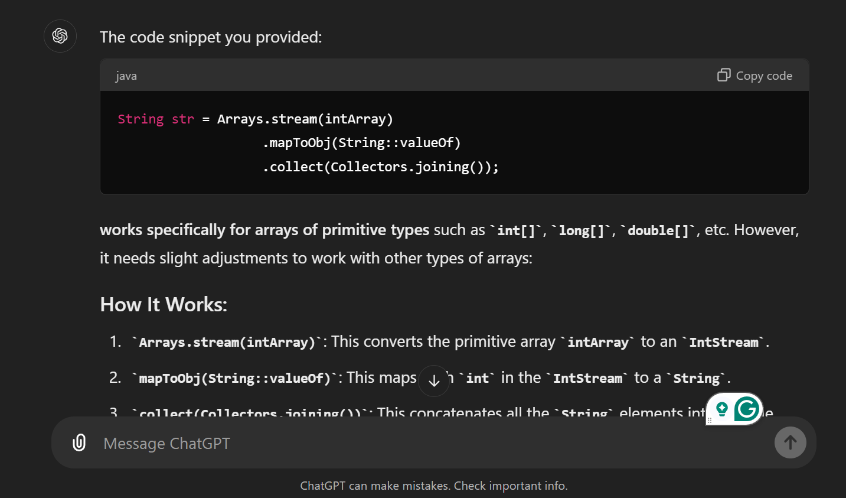
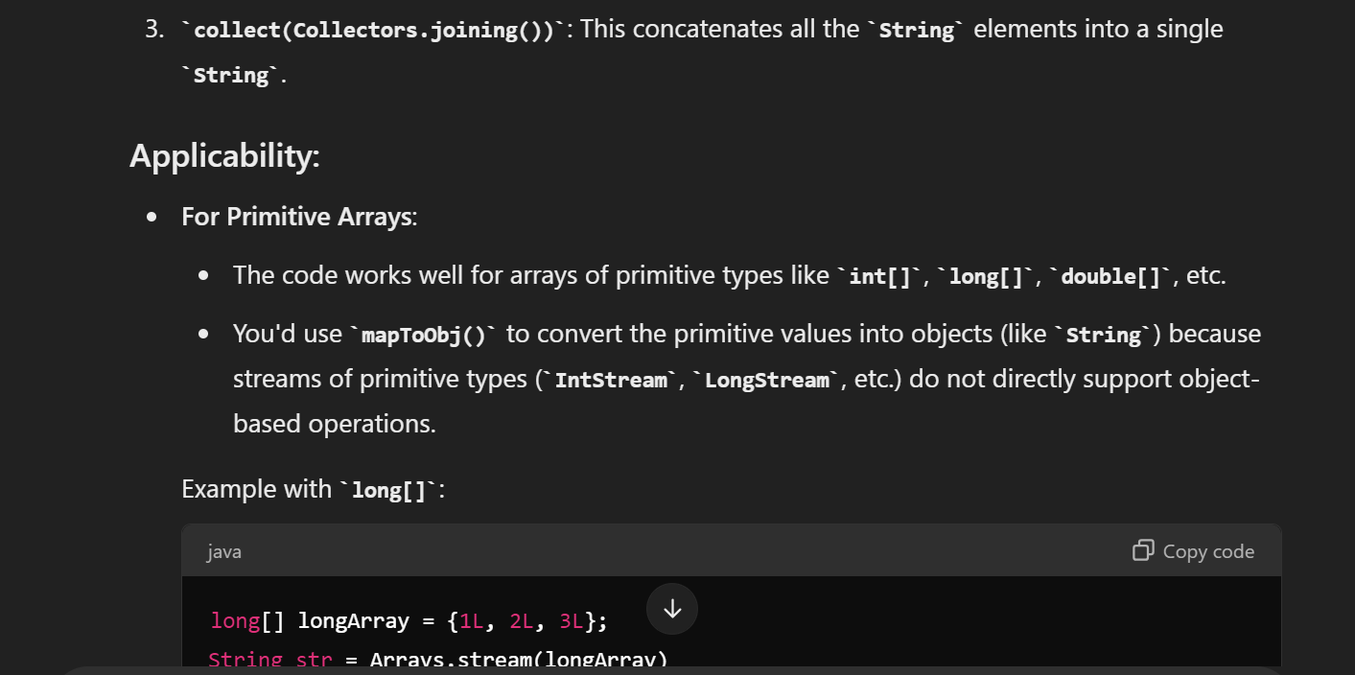
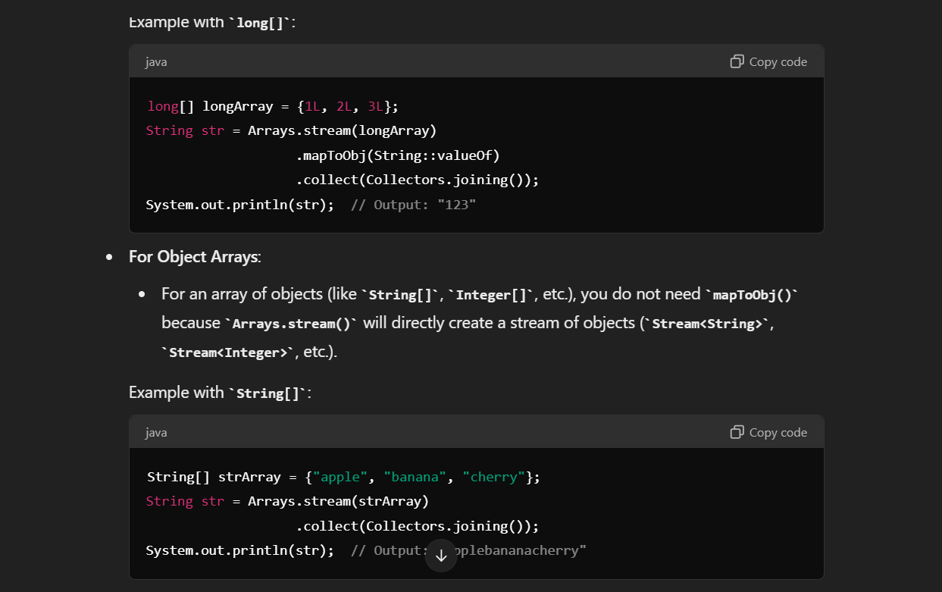
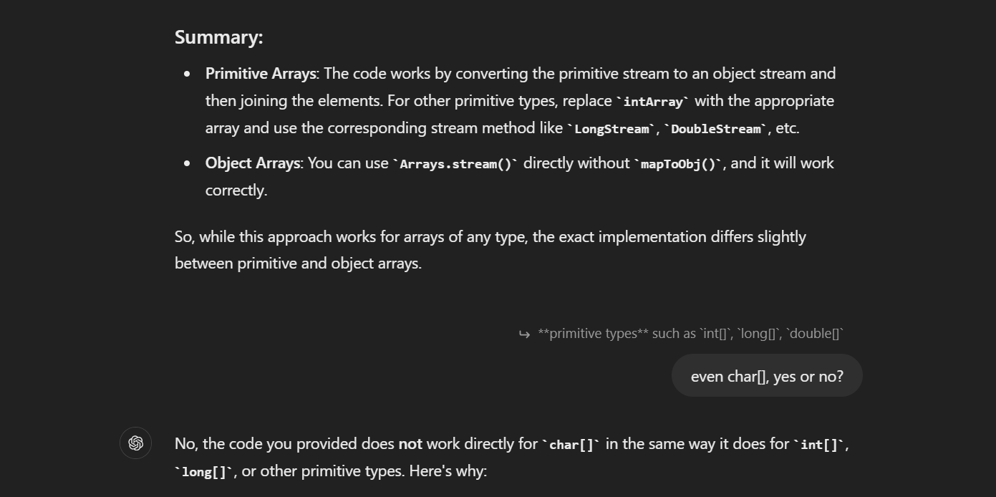
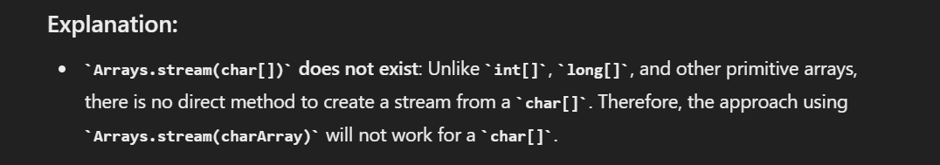

- HashMap in Java:
- The data structure implements the Map interface by storing key-value pairs and providing efficient lookup, insertion, and deletion operations.
- Unlike HashSet, which stores unique elements, a HashMap allows duplicate values to be associated with different keys.
- While it's not directly a part of the Collection interface, it's a member of the Map interface, which is a top-level interface in the Java Collections Framework. The Map interface is designed to store key-value pairs, and HashMap is a specific implementation of this interface. So, while HashMap doesn't directly implement Collection, it's still considered a collection-like object due to its role in storing and managing data within the Java Collections Framework.
- Operations:
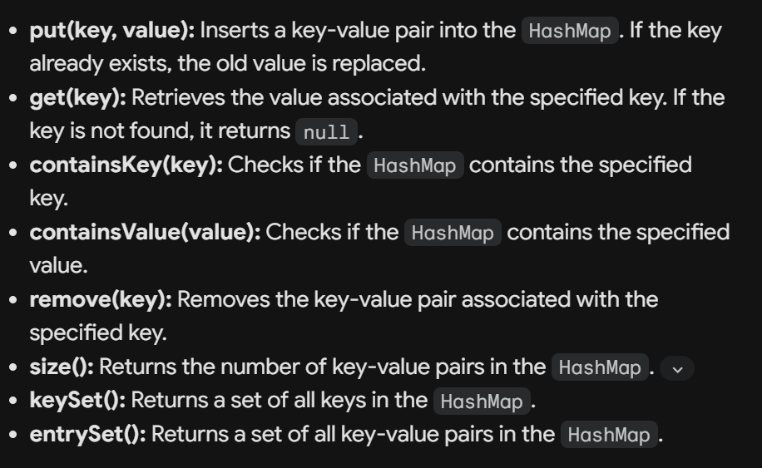
- Key Characteristics:
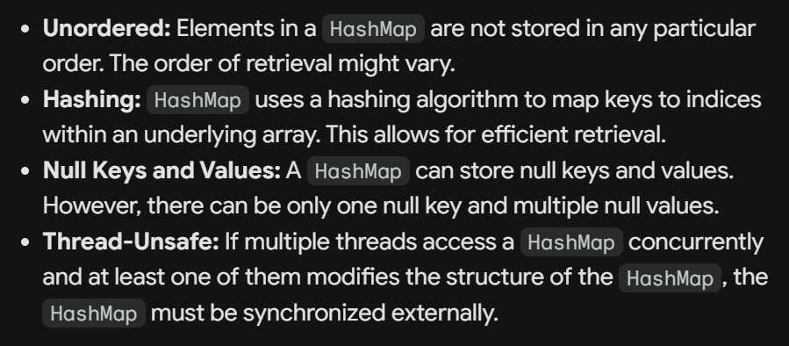
- More important points:
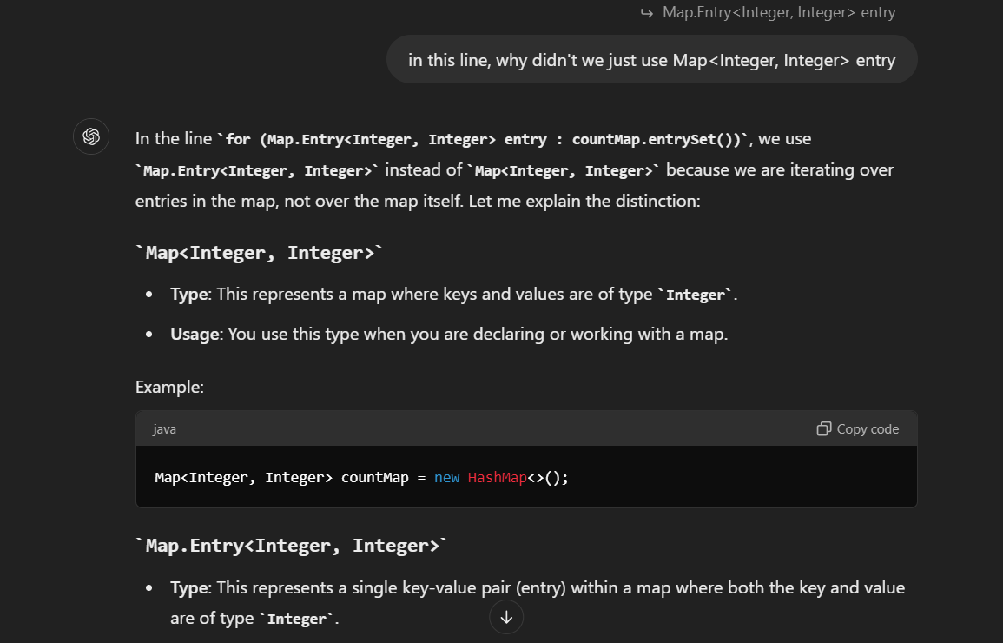

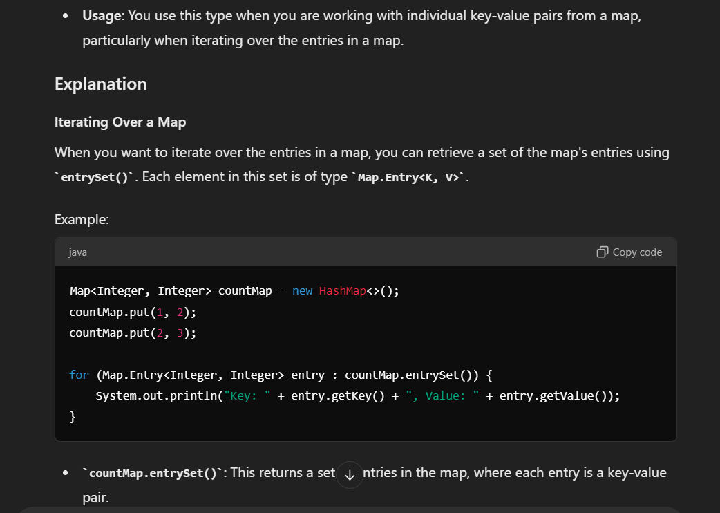
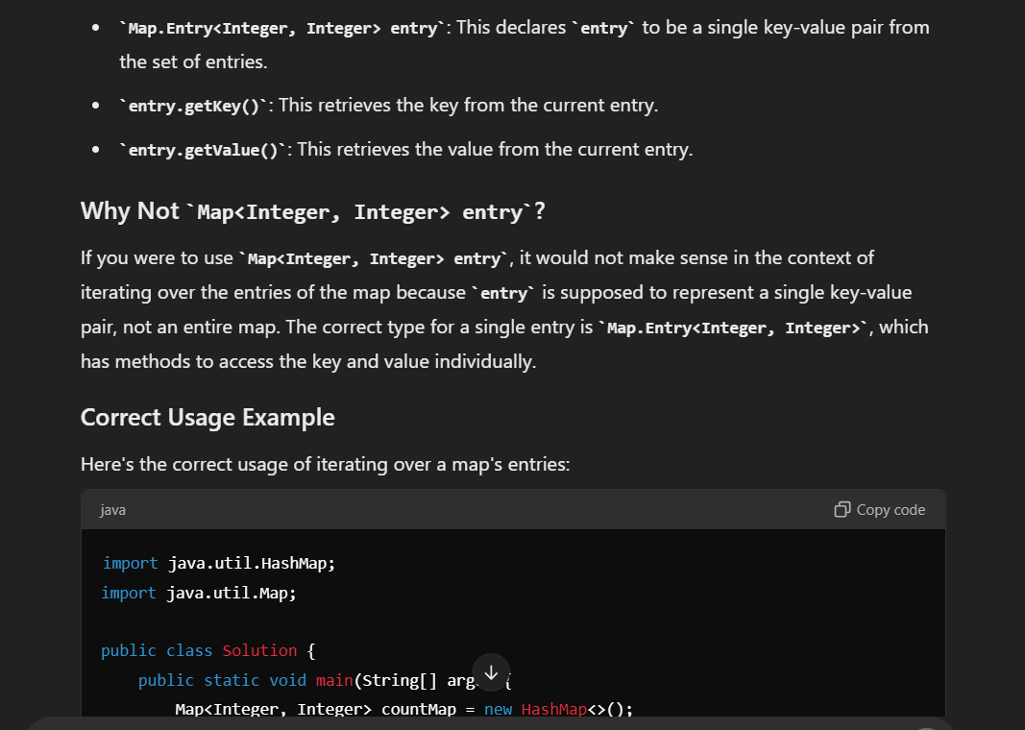

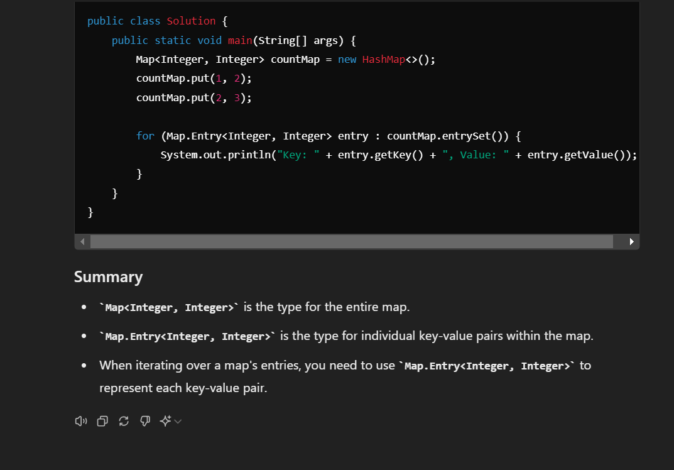

- StringBuffer in Java:
`StringBuffer` in Java is a class that represents a mutable sequence of characters. Unlike `String`, which is immutable (once a `String` object is created, it cannot be changed), `StringBuffer` allows you to modify the contents of the string without creating a new object.

### Key Features of `StringBuffer`:

1. **Mutable**:
- `StringBuffer` objects can be modified after they are created. You can append, insert, or delete characters, and the object itself is modified rather than creating a new object.

2. **Thread-Safe**:
- `StringBuffer` is synchronized, meaning that it is thread-safe. Multiple threads can safely access and modify a `StringBuffer` object simultaneously. This makes it suitable for use in multithreaded environments, but the synchronization adds overhead, making `StringBuffer` slower than `StringBuilder` in single-threaded environments.

3. **Dynamic Size**:
- The size of a `StringBuffer` can grow dynamically as needed. It automatically expands to accommodate the additional characters when you add them.

4. **Performance**:
- Although `StringBuffer` is slower than `StringBuilder` due to its thread safety, it is still faster than `String` when performing multiple modifications because it avoids the overhead of creating new objects for every modification.

### Commonly Used Methods:

- **`append(String str)`**:
- Appends the specified string to the end of the existing sequence.
- Example:
```java
StringBuffer sb = new StringBuffer("Hello");
sb.append(" World");
System.out.println(sb); // Output: "Hello World"
```

- **`insert(int offset, String str)`**:
- Inserts the specified string at the specified position.
- Example:
```java
StringBuffer sb = new StringBuffer("Hello");
sb.insert(5, " World");
System.out.println(sb); // Output: "Hello World"
```

- **`delete(int start, int end)`**:
- Removes the characters in a substring of this sequence. The substring begins at the specified start index and extends to the character at index end - 1.
- Example:
```java
StringBuffer sb = new StringBuffer("Hello World");
sb.delete(5, 11);
System.out.println(sb); // Output: "Hello"
```

- **`reverse()`**:
- Reverses the sequence of characters.
- Example:
```java
StringBuffer sb = new StringBuffer("Hello");
sb.reverse();
System.out.println(sb); // Output: "olleH"
```

- **`toString()`**:
- Converts the `StringBuffer` object to a `String`.
- Example:
```java
StringBuffer sb = new StringBuffer("Hello");
String str = sb.toString();
System.out.println(str); // Output: "Hello"
```

### Differences Between `StringBuffer`, `StringBuilder`, and `String`:

1. **`String`**:
- Immutable: Cannot be changed after creation.
- Thread safety: Not applicable.
- Use when the string content does not change frequently.
2. **`StringBuffer`**:
- Mutable: Can be changed after creation.
- Thread safety: Synchronized, making it thread-safe.
- Use in multithreaded environments where string content changes frequently.
3. **`StringBuilder`**:
- Mutable: Can be changed after creation.
- Thread safety: Not synchronized, so not thread-safe.
- Use in single-threaded environments where string content changes frequently.
### Summary:
- Use `StringBuffer` when you need a mutable sequence of characters and require thread safety.
- For single-threaded environments where performance is a concern, prefer `StringBuilder` over `StringBuffer`. For immutability and simplicity, use `String`.

- How Counting Sort Works:
- Determine the Range:
  - Identify the minimum and maximum values in the input array to determine the range of the values.
- Count Occurrences:
  - Create an auxiliary array (often called the "count array") that has a length equal to the range of input values. Initialize this array with zeros.
  - Traverse the input array, and for each element, increment the corresponding index in the count array. This results in a count of how many times each value appears in the input array.
- Compute Cumulative Counts:
  - Modify the count array such that each element at index i contains the sum of counts up to that index. This step effectively tells you the position of each element in the sorted array.
- Build the Output Array:
  - Iterate over the input array in reverse order. For each element, place it in the correct position in the output array (determined by the cumulative count) and decrement the corresponding count in the count array.
- Copy to Original Array (if needed):
  - If you want the result back in the original array, you can copy the elements from the output array to the original array.
Example:
Let's sort the array [4, 2, 2, 8, 3, 3, 1] using counting sort.
- Determine the Range:
  - The minimum value is 1, and the maximum value is 8. The range is 8 - 1 + 1 = 8.
- Count Occurrences:
  - Create a count array of size 8 (since the range is 8). Initialize it with zeros: [0, 0, 0, 0, 0, 0, 0, 0].
  - Traverse the input array and update the count array:
    - Count of 1: [1, 0, 0, 0, 0, 0, 0, 0]
    - Count of 2: [1, 2, 0, 0, 0, 0, 0, 0]
    - Count of 3: [1, 2, 2, 0, 0, 0, 0, 0]
    - Count of 4: [1, 2, 2, 1, 0, 0, 0, 0]
    - Count of 8: [1, 2, 2, 1, 0, 0, 0, 1]
- Compute Cumulative Counts:
  - Modify the count array to get cumulative counts:
    - [1, 3, 5, 6, 6, 6, 6, 7]
- Build the Output Array:
  - Traverse the input array in reverse, placing elements in the correct positions in the output array:
    - Place 1 at position 0: [1, 0, 0, 0, 0, 0, 0]
    - Place 2 at position 2: [1, 2, 2, 0, 0, 0, 0]
    - Place 3 at position 4: [1, 2, 2, 3, 3, 0, 0]
    - Place 4 at position 5: [1, 2, 2, 3, 3, 4, 0]
    - Place 8 at position 6: [1, 2, 2, 3, 3, 4, 8]
- Result:
  - The output array is [1, 2, 2, 3, 3, 4, 8].
Time Complexity:
- O(n + k) where n is the number of elements in the input array, and k is the range of the input values.
Space Complexity:
- O(n + k) because it requires additional space for the count array and the output array.
Key Points:
- Counting sort is stable: Elements with the same value appear in the output array in the same order as they do in the input array.
- Counting sort is efficient for small ranges: It works best when the range of the input values (k) is not significantly larger than the number of elements (n).
- Not a comparison-based sort: Unlike quicksort or mergesort, counting sort does not compare elements directly but rather counts occurrences.

